RESOLUTION NO.__________

RE: CERTIFICATE OF APPROPRIATENESS UNDER THE
PROVISIONS OF THE ACT OF THE PENNSYLVANIA
LEGISLATURE 1961, JUNE 13, P.L. 282 (53
SECTION 8004) AND BETHLEHEM ORDINANCE NO.
3952 AS AMENDED.

WHEREAS, it is proposed to replace the existing roof overhang and built-in gutters at 738 E 4th St.

NOW, THEREFORE, BE IT RESOLVED by the Council of the City of Bethlehem that a Certificate of Appropriateness is hereby granted for the work.

Sponsored by: (s)

(s)

ADOPTED BY COUNCIL THIS DAY OF

(s)
President of Council

ATTEST:

(s)
City Clerk

HISTORIC CONSERVATION COMMISSION

CASE # 501 – It is proposed to replace the existing roof overhang and built-in gutters at 738 E 4th St.
OWNER/APPLICANT: Herminio Berrios

The Commission upon motion by Mr. Roeder seconded by Mr. Cornish adopted the proposal that City Council issue a Certificate of Appropriateness for the proposed work described herein:

- The proposal to replace the existing roof overhang and built-in gutters at 738 E 4th St was presented by Herminio Berrios and Jose San Miguel.

- The existing box gutter may be removed as proposed.

- A new frame overhang structure will be constructed and clad in white Azek or similar solid PVC material.

- White 6” K style gutter with return will be attached to the front of the new fascia and approximately align with the box gutter of the attached building.

- A round aluminum downspout will be used. The aluminum downspout may transition to painted PVC at street level to better resist damage. The color of the downspouts may be brown to blend better with the existing brick color.

- The dormer woodwork will be replaced with Azek.
- The existing dormer crown molding will be replaced with Fypon material to match the existing as closely as possible in size and scale.

- The proposed motion was unanimously approved.
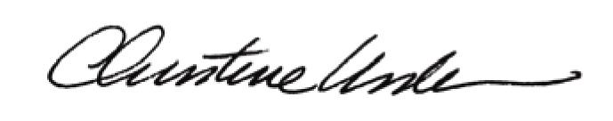

By:

Date of Meeting: June 16, 2014 Title: Historic Officer

